# *CURRICULUM VITAE*

## Magdalena Agnieszka Wrzesińska

Date and place of birth:

Nationality:

Telephone number:

E-mail:

09 December 1979, Łódź

Polish

00-48-693-037-010

magdalena.wrzesinska@umed.lodz.pl

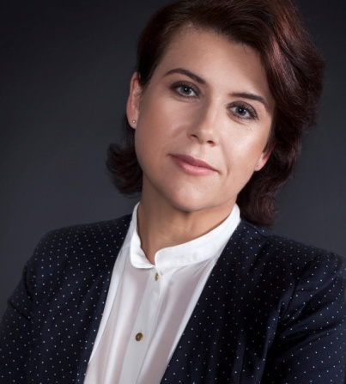

**PROFESSIONAL EXPERIENCE**

|  |  |
| --- | --- |
| From 2013 | Head of the Department of Psychosocial Rehabilitation, Medical University of Lodz, Poland |
| From 2012 | Assistant Professor in Department of Psychosocial Rehabilitation, Medical University of Lodz, Poland  Research areas: health education, obesity, physical activity, psychosocial determinants of health and disabilities, behavioral addiction, technology transfer models |
| From 2015 | Tutor in the Interdisciplinary School of Innovation at the Technical University of Lodz and Medical University of Lodz, Poland |
| 2007 –2012 | Research assistant in Department of Psychosocial Rehabilitation, Medical University of Lodz, Poland  Research areas: psychosocial determinants of health and disabilities, psychosocial determinants of substance addictions. |
| 2003-2007 | Department of Psychosocial Rehabilitation, Medical University of Lodz, Poland, Phd Student  Research area: psychosocial determinants of digestive system, CHD |
| 2003-2006 | Department of Public Health at the City of Lodz Office, Poland:  prevention projects, health educator |
| 2004-2006 | The City Centre of Preventive Medicine in Lodz, Poland:  courses in addiction prevention among children and youngsters |
|  |  |

### **PROFESSIONAL EDUCATION**

|  |  |
| --- | --- |
| 1998-2003 | Medical University of Lodz, Poland, public health |
| 2003-2007 | Postgraduate Doctoral Study, Medical University of Lodz, Poland |
| 2012 -2013 | University of Lodz; Medical University of Lodz; Technical University of Lodz, University of Texas at Austin, Postgraduate Study: Manager of BioTechScience |
| 2013 | Study visit at Lund University, Sweden (innovations and model technology transfer skills) |
| 2016 | ETC-Summer Course, Wageningen University, The Netherlands |
| 2017 | Innostar StarShip Falloship, EIT Health |

**RESEARCH INTERESTS**

|  |
| --- |
| * Innovation, Universal Design, Design Thinking * Health education, evaluation |
| * Determinants of obesity, physical activity * Determinants of behavioral addictions * Psychological and social aspects of disabilities |

FOREIGN LANGUAGES

|  |  |
| --- | --- |
| **English** | Level 1 Certificate in English (2003) |
| **German** | Zertifikat Deutsch (2006) |
| **Italian** | l'esame „CILS” per la certificazione di italiano „Livello A2” (2012) |
| **CERTIFICATES** | |
| * The Certificate of Recognition of a Mastery of the Science and Technology Commercialization Body of Knowledge. The University of Texas at Austin (2013) * Certificate of Registration in EUIPO No 003057090-0001 “Healthy Lifestyle   Pyramid” (2016) | |

**MEMBERSHIP IN THE SCIENTIFIC SOCIETIES AND ASSOCIATIONS:**

Since 2013, the Polish Drug Prevention Society

Since 2014, the Polish Rehabilitation Society

Since 2016, the Club of Innovative Scientists, Poland

## Since 2016, International Union for Health Promotion and Education